DS.140 Integration Design Specification



BPA PaaS Approval Validations Integration

SCM_RICE_360

Author: Pranjul Garg

Creation Date: May 16, 2022

Last Updated: Dec 18 , 2024

Version: 1.0

**Approvals:**

|  |  |
| --- | --- |
| <Approver 1> | <Rakesh Khanna / Naushad / Amit> |
| <Approver 2> | <Business Owner> |

**Error! AutoText entry not defined.**

# Document Control

## Change Record

| Date | Author | Version | Change Reference |
| --- | --- | --- | --- |
| 16-May-2022 | Pranjul Garg | 1.0 | No Previous Document |
|  |  |  |  |
|  |  |  |  |
|  |  |  |  |

3

## Reviewers

| Name | Position |
| --- | --- |
| FHL Business | Business User |
| FHL IT Group | Fortis IT Team |
|  |  |
|  |  |

Contents

1 Document Control i

1.1 Change Record i

1.2 Reviewers i

2 Introduction 1

2.1.1 Scope for this Document 1

2.1.2 Intended Audience 1

3 Overview 1

3.1 Business Objectives 1

3.2 Major Features 1

3.3 Glossary 1

4 High-Level HIS to Fusion Integration flow 1

5 Technical Design Details 1

5.1 OIC Services 1

5.2 Oracle PaaS DBCS components 1

5.3 Technical flow 1

6 Data FIELD Mapping 1

6.1 File format 1

6.2 Frequency 1

7 Exception handling 1

7.1 Scenarios 1

8 Assumptions / Considerations 1

9 Open and Closed Issues 1

9.1 Open Issues 1

9.2 Closed Issues 1

# Introduction

### Scope for this Document

This analysis specification document is prepared to layout the BPA PaaS approval validation integration.

### Intended Audience

This document is intended for the following groups to provide the action items and consideration that are required to complete the implementation of the various Supply Chain and Finance related functionalities from Oracle Fusion.

#### Fortis Business Users

This document will be helpful for Fortis Business users to understand the technical design and process change with the new structure implemented in Oracle. The business user will validate this document after the verification of the requirement.

#### PwC Technical Team

The PwC technical team will use this document as a source technical design document to develop the technical solution to implement / deploy in Oracle Fusion.

#### Fortis IT Team

The Fortis IT Team must facilitate the PwC technical team for requisite details and other elements required from Business. The Fortis IT team is also responsible to arrange and provide required technical information wherever is required.

# Overview

Fortis Healthcare Limited (FHL) is a chain of hospitals, headquartered in India. Fortis started its health care operations from Mohali where first Fortis hospital was started. Later, the hospital chain purchased the healthcare branch of the Escorts group and increased its strength in various parts of the country. The Fortis health care also operates its hospital in Vasant Kunj, Faridabad, Gurgaon. The FMRI hospital at Gurgaon is the headquarter of Fortis healthcare with all the major facilities at the hospital.

This specification document is prepared to layout the design of BPA PaaS approval validation integration. Oracle PaaS DBCS has been used for validating the data before approving the BPA from a dummy user.

## Business Objectives

The following are the business objectives.

1. To have a secure, reliable, and scalable design flow to validate all the BPAs which are submitted for approval via the PaaS DBCS database.
2. To have a solution providing the monitoring capabilities.

## Major Features

The proposed solution will have the following features involved:

1. A dummy user has been created in Oracle Fusion and configured as a first level approval for all the BPAs. Actual business approval hierarchy starts once the given BPA is approved from this dummy user.
2. The PLSQL code has been written which fetches the BPA which are pending for approval with this dummy user, validates the PO data and finally act accordingly.

## Glossary

REST

Representational State Transfer.

OIC

Oracle Integration Cloud

# High-Level HIS to Fusion Integration flow

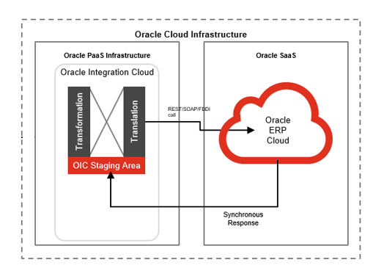

# Technical Design Details

This section describes the technical details of all the components involved in the design of PaaS approval validation integration for BPA.

Integration fetches the BPA pending for approval with “Fortis Sysadmin” user

Integration performs data validation

Invoked procedures then triggers Fusion BPM REST API, BPA is approved by Fortis Sysadmin, followed by GAM approvals

Accepted

Rejected

Status is updated to “Rejected” and process flag is set to “E”

## OIC Services

An App driven orchestration has been designed in OIC to build a REST Endpoint URL, which triggers a PLSQL procedure to process the PRs.

|  |  |
| --- | --- |
| **OIC Integration Name** | Fortis Trigger PaaS App Validation Integration |
| **OIC REST Endpoint URL** | https://oic-prod-nr5lr39yailj-bo.integration.ocp.oraclecloud.com:443/ic/api/integration/v1/flows/rest/FORTI_TRIGG_PAAS_APP_VALID_INTG/1.0/paas/approvalValidation/ |
| **Method** | POST |

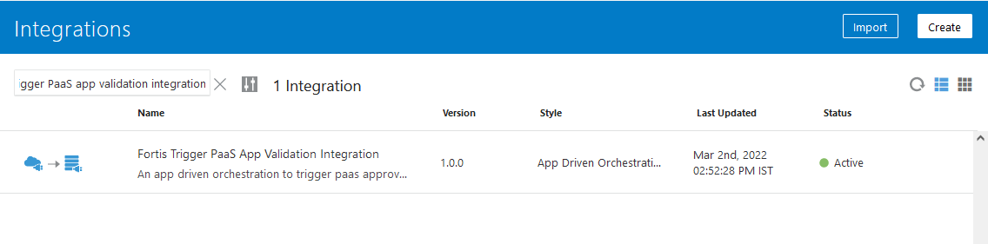

## Oracle PaaS DBCS components

This integration design uses the following components from Oracle PaaS DBCS:

|  |  |  |
| --- | --- | --- |
| **DB Component** | **Component name** | **Details** |
| **Tables** | xxfh_saas_validations_tbl | This is a common table where all the PR/PO/BPA records are stored which are getting processed via the PaaS approval validation integration. |
| xxfh_wftask | This is BPM task table which contains the details of approval notification with its complete details. |
| **Package** | XXFH_SAAS_APP_VALIDATION_PKG | This package contains a procedure xxfh_validate_bpa_prc which basically fetches the BPAs which are pending for approval with “Fortis Sysadmin”, validates them and finally approve/reject them. |

## Technical flow

Following is the complete technical flow for this integration design:

1. A common scheduled OIC integration (Fortis Trigger 10m Integration) invokes this BPA PaaS approval validation integration at every 10 minutes.
2. Once the OIC integration is invoked, it internally invokes the PLSQL procedure xxfh_saas_app_validation_pkg.xxfh_validate_bpa_prc. This procedure has a following master cursor query which fetches the BPA pending for approval with “Fortis Syadmin” user.

SELECT wft.tasknumber task_number,

poh.segment1 trx_number,

poh.po_header_id trx_id,

'BPA' trx_type

FROM xxfh_wftask wft, xxfh_po_headers_all poh

WHERE wft.category = 'Purchasing'

AND wft.taskdefinitionname = 'DocumentApproval'

AND wft.state = 'ASSIGNED'

AND wft.workflowpattern <> 'FYI'

AND wft.identificationkey LIKE

'PA_' || poh.po_header_id || '%'

AND wft.title LIKE '%' || poh.segment1 || '%'

AND NVL (poh.document_status, 'OPEN') IN ('OPEN',

--mod for ver 2.00 starts

'CLOSED',

--mod for ver 2.00 ends

'PENDING APPROVAL',

'PENDING CHANGE APPROVAL')

AND poh.type_lookup_code = 'BLANKET'

AND wft.assignees = p_username || ',user'

AND NOT EXISTS

(SELECT 1

FROM xxfh_saas_validations_tbl b

WHERE wft.tasknumber = b.task_number

AND b.trx_id = poh.po_header_id

AND b.trx_type = 'BPA');

1. The procedure further loops through each & every BPA record and validates them as per the following validations.

* Another BPA <bpa_num> in BU <Req_bu_name> is available for the item <item_number>.
* Item(s) <item_number> is(are) added in the lines <line_num>. Please ensure that the item is not repeated across BPA lines.
* Scheme dates are not within the BPA dates. Please ensure that the scheme dates are within the agreement header and line dates.
* Item included is not a consigned item. Please ensure that only consigned items are included in the PO.

1. Once a BPA is validated from all the above validations, it invokes procedure xxfh_saas_app_validation_pkg .xxfh_call_approval_api to take action on the BPM approval task for the given BPA.
2. This procedure invokes Fusion BPM REST API via the apex_web_service.make_rest_request function.

**Server details:**

|  |  |  |  |  |
| --- | --- | --- | --- | --- |
| **Server** | **Host name** | **Port** | **Service Name** | **Username** |
| Oracle PaaS DB | 140.238.225.129 | 1521 | PRODPDB1.fhpubsn.fhvcn.oraclevcn.com | XXFH & XXFH_RO |

**Oracle PaaS Table design:**

* + - 1. Table: XXFH_SAAS_VALIDATIONS_TBL

|  |  |  |  |  |
| --- | --- | --- | --- | --- |
| **S.No.** | **Table Column** | **Data Type** | **Length** | **Remarks** |
| 1 | OIC_FLOW_ID | NUMBER | 22 |  |
| 2 | TASK_NUMBER | VARCHAR2 | 50 | Task number for the BPM approval notification |
| 3 | TRX_ID | NUMBER | 22 | requisition_header_id if TRX_TYPE = 'PR' po_header_id if TRX_TYPE = 'PO' or 'BPA' |
| 4 | TRX_NUMBER | VARCHAR2 | 50 | requisition number if TRX_TYPE = 'PR', PO Number if TRX_TYPE = 'PO', BPA Number if TRX_TYPE = 'BPA' |
| 5 | TRX_TYPE | VARCHAR2 | 50 | PR/PO/BPA |
| 6 | ACTION | VARCHAR2 | 20 | APPROVE/REJECT |
| 7 | COMMENTS | VARCHAR2 | 4000 |  |
| 8 | API_STATUS_CODE | VARCHAR2 | 240 |  |
| 9 | API_RESPONSE | CLOB | 4000 |  |
| 10 | PROCESS_FLAG | VARCHAR2 | 1 |  |
| 11 | ERROR_MESSAGE | VARCHAR2 | 4000 |  |
| 12 | CREATION_DATE | DATE | 7 | WHO columns |
| 13 | CREATED_BY | VARCHAR2 | 20 |
| 14 | LAST_UPDATE_DATE | DATE | 7 |
| 15 | LAST_UPDATED_BY | VARCHAR2 | 20 |

* + - 1. Table: XXFH_WFTASK

|  |  |  |  |  |
| --- | --- | --- | --- | --- |
| **S.No.** | **Table Column** | **Data Type** | **Length** | **Remarks** |
| 1 | ASSIGNEES | VARCHAR2 | 4000 | User name with whom the notification is pending |
| 2 | ASSIGNEESDISPLAYNAME | VARCHAR2 | 4000 |  |
| 3 | CREATOR | VARCHAR2 | 4000 |  |
| 4 | ASSIGNEDDATE | TIMESTAMP(6) WITH TIME ZONE | 13 |  |
| 5 | CREATEDDATE | TIMESTAMP(6) WITH TIME ZONE | 13 |  |
| 6 | FROMUSER | VARCHAR2 | 4000 |  |
| 7 | FROMUSERDISPLAYNAME | VARCHAR2 | 4000 |  |
| 8 | STATE | VARCHAR2 | 4000 | ASSIGNED if the notification is pending for approval |
| 9 | TASKNUMBER | VARCHAR2 | 4000 | Unique number of the notification |
| 10 | UPDATEDBY | VARCHAR2 | 4000 |  |
| 11 | UPDATEDBYDISPLAYNAME | VARCHAR2 | 4000 |  |
| 12 | UPDATEDDATE | TIMESTAMP(6) WITH TIME ZONE | 13 |  |
| 13 | WORKFLOWPATTERN | VARCHAR2 | 4000 |  |
| 14 | TITLE | VARCHAR2 | 4000 | Approval notification subject |
| 15 | IDENTIFICATIONKEY | VARCHAR2 | 4000 | Key column which identifies the base transaction for which the notification is pending for approval |



**Validation was applied through Personalization after this went live:**

Expression changes made to Change Order Screen for Blanket Purchase Agreement on the line level by clicking on edit pages.

* Replace existing condition with below expression under discount type field on change order screen

#{bindings.ChangeOrderFlag.inputValue == 'Y'}

* Replace existing condition with below expression under discount reason and discount fields on change order screen

#{row.DiscountType null or bindings.ChangeOrderFlag.inputValue 'Y'}

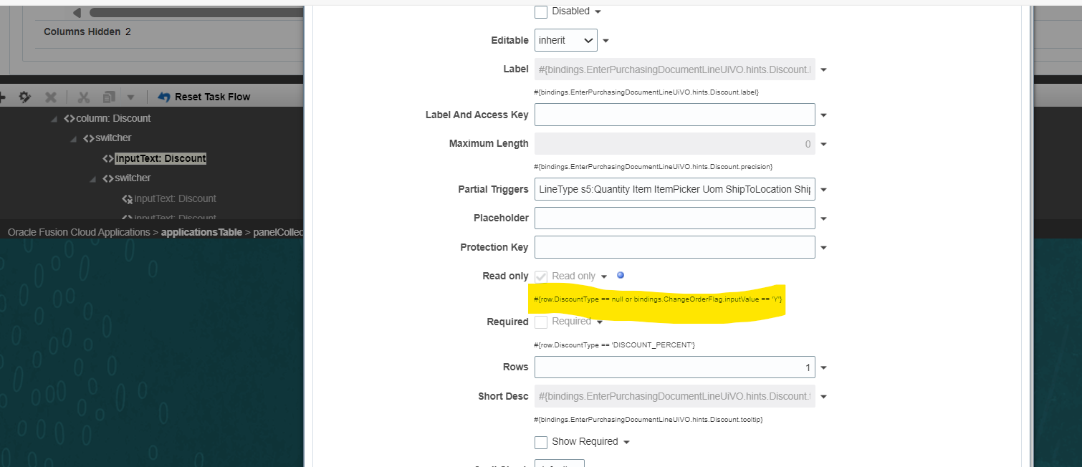

The following conditions will be added through sandbox on the Change Order Screen at line level by clicking on the pencil icon and opening the Edit Line Page:

* Replace existing condition with below expression under discount type field on change order screen

#{bindings.ChangeOrderFlag.inputValue == 'Y'}

* Replace existing condition with below expression under discount reason and discount fields on change order screen

#{bindings.ChangeOrderFlag.inputValue == 'Y'}

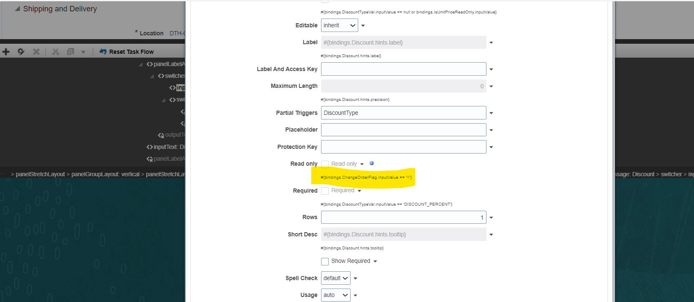

# Data FIELD Mapping

NA

## File format

NA

## Frequency

The PaaS approval validation integration is scheduled to run every 10 minutes.

# Exception handling

There can be various scenarios for an error to occur. This section defines those error scenarios and the exception handling has been done to notify and act accordingly.

## Scenarios

In a tabular format give list of scenarios and exception handling

* If any of the step or node fails within the OIC integration, Global Fault section is configured within this OIC integration to send an OIC error notification with relevant details.
* The email id has been stored in OIC Lookup: Fortis_FaultNotification_EmailAddress_Lookup against the given OIC integration name.
* It also sends a notification every 10 mintes with the details of the PR/PO/BPA which have been processed in the given run. This notification also acts as a confirmation that the integration has been running fine.

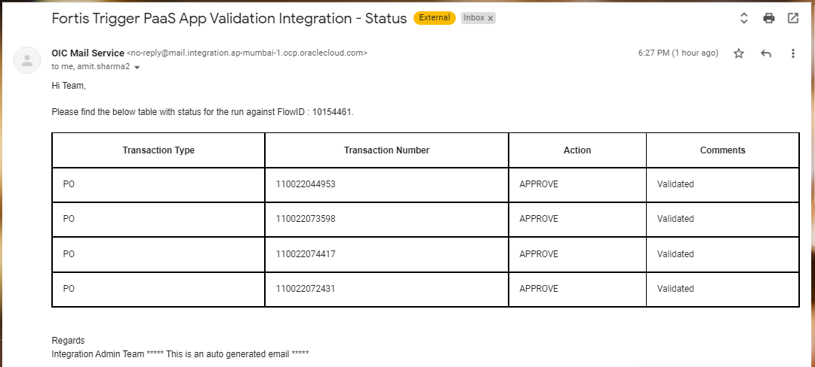

# Assumptions / Considerations

The Proposed Solution will have the following technical considerations.

In the future, if any product bug arises in functionality then this process needs to be revisited after the bug is fixed.

# Open and Closed Issues

## Open Issues

| ID | Issue | Resolution | Responsibility | Target Date | Impact Date |
| --- | --- | --- | --- | --- | --- |
|  |  |  |  |  |  |
|  |  |  |  |  |  |
|  |  |  |  |  |  |
|  |  |  |  |  |  |

## Closed Issues

| ID | Issue | Resolution | Responsibility | Target Date | Impact Date |
| --- | --- | --- | --- | --- | --- |
|  |  |  |  |  |  |
|  |  |  |  |  |  |
|  |  |  |  |  |  |
|  |  |  |  |  |  |